
Happy Halloween
Crispitos
Salsa, Sour Cream
Black Beans, Corn
Pineapple, Strawberries
Chocolate Chip Cookie
Juice
Milk


Alternate meal options include PB&J Grab & Go, Yogurt Grab & Go, Buffalo or Plain Chicken Wrap, or Turkey Chef Salad. Fruits and vegetables are offered on all options.
Meat options are not offered on Fridays. This menu is subject to change by product availability.
This institution is an equal opportunity employer.

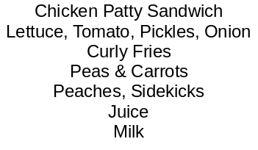
Cheese Ravioli with Marinara
Garlic Breadstick
Garden Salads
Applesauce
Orange Slices
Juice
Milk

Chicken Drumstick
Dinner Roll
Mashed Potatoes & Gravy
Green Beans
Pears, Grapes
Juice
Milk

Mini Corn Dogs
Carrot Sticks
Corn
Mandarin Oranges
Apples
Juice
Milk

Cheese Pizza
OR Pepperoni Pizza
Steamed Broccoli
Garden Salads
Pineapple, Strawberries
Juice
Milk

Hamburger
OR Cheeseburger
Potato Wedges, Baked Beans
Peaches, Sidekicks
Pickle Slices
Juice
Milk

Chicken Nuggets
Macaroni & Cheese
Green Beans
Glazed Carrots
Pears, Grapes
Juice
Milk

Confetti Pancakes
Egg Omelet
Tater Tots, Celery Sticks
Mandarin Oranges
Apples
Juice
Milk

Chicken Tenders
Dinner Roll
Mashed Potatoes & Gravy
Green Beans
Pears, Grapes
Juice
Milk

Chili Spaghetti
Shredded Cheese, Onions
Oyster Crackers
Corn, Carrot Sticks
Mandarin Oranges, Apples
Juice
Milk

Cheese Pizza
OR Pepperoni Pizza
Steamed Broccoli
Garden Salads
Pineapple, Strawberries
Juice
Milk

OCTOBER 2025
Holy Cross & St. Patrick HS Lunch Menu
Mini Waffles
Egg Omelet
Tater Tots, Celery Sticks
Mandarin Oranges
Apples
Juice
Milk

Chicken Nuggets
Macaroni & Cheese
Green Beans
Glazed Carrots
Pears, Grapes
Juice
Milk

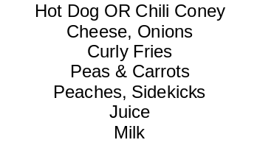
Hamburger
OR Cheeseburger
Potato Wedges, Baked Beans
Peaches, Sidekicks
Pickle Slices
Juice
Milk

Mini Waffles
Egg Omelet
Tater Tots, Celery Sticks
Mandarin Oranges
Apples
Juice
Milk

Chicken Nuggets
Macaroni & Cheese
Green Beans
Glazed Carrots
Pears, Grapes
Juice
Milk

Cheese Bites
Marinara Sauce
Seasoned Broccoli
Garden Salads
Applesauce, Orange Slices
Juice
Milk

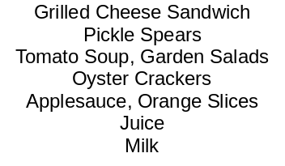
Soft Taco OR Nacho Taco
Cheese, Salsa, Sour Cream
Black Beans, Corn
Pineapple, Strawberries
Carnival Cookie
Juice
Milk

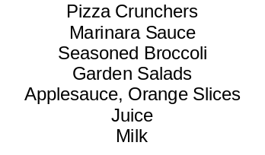
Monster Cheese Bites
Marinara Sauce
Seasoned Broccoli
Garden Salads
Spooky Strawberries
Franken-Kiwi
Juice, Milk

Student Meal $3.45
Adult Meal $5.00
Extra Entrée $2.20
Extra Fruit/Veg $.60
Extra Juice/Milk $.60
Bottled Water $1.00
Ala Carte Snacks & Beverages $.60 - $2.00

