
Student Meal $0.00
Adult Meal $5.00
Extra Entrée $2.00
Extra Fruit/Veg $.60
Extra Juice/Milk $.60
Ice Cream $1.00
Ice cream will be available once per week.

Hamburger
OR Cheeseburger
Potato Wedges
Baked Beans
Peaches, Sidekicks
Juice
Milk


Alternate meal options include PB&J Grab & Go, Yogurt Grab & Go, or Turkey Chef Salad. Fruits & Vegetables offered with all options.
Meat options not available on Fridays. Menu subject to change by product availability.
This institution is an equal opportunity employer.

Cheese Bites
Marinara Sauce
Seasoned Broccoli
Garden Salads
Applesauce, Orange Slices
Juice
Milk

Hot Dog
OR Chili Coney
Shredded Cheese, Onions
Curly Fries, Peas & Carrots
Peaches, Sidekicks
Juice
Milk

NOVEMBER 2025
CEP Elementary Lunch Menu
No School
Cheese Pizza
OR Pepperoni Pizza
Seasoned Broccoli
Garden Salads
Pineapple, Strawberries
Juice
Milk

Roasted Turkey
Dinner Roll, Stuffing
Mashed Potatoes & Gravy
Green Beans
Pears, Grapes
Pumpkin Pie
Juice, Milk

Chicken Nuggets
Macaroni & Cheese
Green Beans
Glazed Carrots
Pears, Grapes
Juice
Milk

Mini Corn Dogs
Tater Tots
Garden Salads
Mandarin Oranges
Apples
Juice
Milk

Soft Taco OR Nacho Taco
Cheese, Salsa, Sour Cream
Black Beans, Corn
Pineapple, Strawberries
Carnival Cookie
Juice
Milk

Chicken Patty Sandwich
Curly Fries
Peas & Carrots
Peaches, Sidekicks
Juice
Milk

Pizza Crunchers
Marinara Sauce
Seasoned Broccoli
Garden Salads
Applesauce, Orange Slices
Juice
Milk

Chicken Nuggets
Macaroni & Cheese
Green Beans
Glazed Carrots
Pears, Grapes
Juice
Milk

Confetti Pancakes
Egg Omelet
Tater Tots, Celery Sticks
Mandarin Oranges, Apples
Syrup Cups
Juice
Milk
Chicken Quesadilla
OR Cheese Quesadilla
Salsa, Sour Cream
Black Beans, Corn
Pineapple, Strawberries
Chocolate Chip Cookie
Juice, Milk

Crispitos
Corn, Celery Sticks
Mandarin Oranges
Apples
Juice
Milk

Cheese Ravioli with Marinara
Garlic Breadstick
Garden Salads
Applesauce
Orange Slices
Juice
Milk

No School
Happy Thanksgiving!
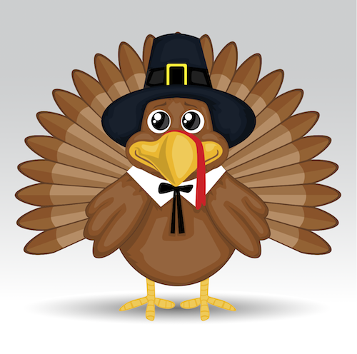
Cheese Pizza
OR Pepperoni Pizza
Seasoned Broccoli
Garden Salads
Pineapple, Strawberries
Juice
Milk

Hamburger
OR Cheeseburger
Potato Wedges
Baked Beans
Peaches, Sidekicks
Juice
Milk

