
Student Meal $3.45
Adult Meal $5.00
Extra Entrée $2.20
Extra Fruit/Veg $.60
Extra Juice/Milk $.60
Bottled Water $1.00
Ala Carte Snacks & Beverages $.60 - $2.00

Chicken Patty Sandwich
Lettuce, Tomato, Pickles, Onion
Onion Rings, Green Beans
Cucumbers & Red Peppers
Peaches, Sidekicks
Juice
Milk


Alternate meal options include PB&J Grab & Go, Yogurt Grab & Go, Buffalo or Plain Chicken Wrap, or Turkey Chef Salad. Fruits and vegetables are offered on all options.
Meat options are not offered on Fridays. This menu is subject to change by product availability.
This institution is an equal opportunity employer.

Grilled Cheese
OR Crispy Fish Sandwich
Au Gratin Potatoes
Garden Salads, Pickle Spears
Tomato Soup, Oyster Crackers
Applesauce, Orange Slices
Juice, Milk

Hamburger
OR Cheeseburger
Lettuce, Tomato, Pickles, Onion
Potato Wedges, Baked Beans
Peaches, Sidekicks
Juice
Milk

NOVEMBER 2025
High School Lunch Menu
No School
Chili Spaghetti
Shredded Cheese, Diced Onions
Oyster Crackers
Glazed Carrots, Garden Salads
Pineapple Tidbits, Strawberries
Juice
Milk

Walking Taco OR Soft Taco
Shredded Cheese, Lettuce
Onion, Salsa, Sour Cream
Black Beans, Corn
Pears, Grapes
Chocolate Chip Cookie
Juice, Milk

Chicken Nuggets
Dinner Roll
Mashed Potatoes & Gravy
Green Beans, Carrot Sticks
Pears, Grapes
Juice
Milk

Cheese Pizza
OR Pepperoni Pizza
Seasoned Broccoli
Garden Salads
Mandarin Oranges, Apples
Juice
Milk

General Tso’s Chicken
Brown Rice
Peas & Carrots, Corn
Pineapple Tidbits
Strawberries
Juice
Milk

Hamburger
OR Cheeseburger
Lettuce, Tomato, Pickles, Onion
Potato Wedges, Baked Beans
Peaches, Sidekicks
Juice
Milk

Crispy Fish Sandwich
OR Grilled Cheese
Au Gratin Potatoes
Garden Salads, Pickle Spears
Tomato Soup, Oyster Crackers
Applesauce, Orange Slices
Juice, Milk

Roasted Turkey
Dinner Roll, Stuffing
Mashed Potatoes & Gravy
Green Beans, Glazed Carrots
Pears, Grapes
Pumpkin Pie
Juice, Milk

Cheese Pizza
OR Pepperoni Pizza
Seasoned Broccoli
Garden Salads
Mandarin Oranges, Apples
Juice
Milk

Crispitos
Brown Rice
Peas & Carrots, Corn
Pineapple Tidbits
Strawberries
Juice
Milk

Chicken Tenders
Mini Waffles
Tater Tots, Celery Sticks
Mandarin Oranges, Apples
Syrup Cups
Juice
Milk

Pizza Crunchers
Marinara Sauce
Curley Fries, Seasoned Broccoli
Garden Salads
Applesauce, Orange Slices
Juice
Milk

No School
Happy Thanksgiving!
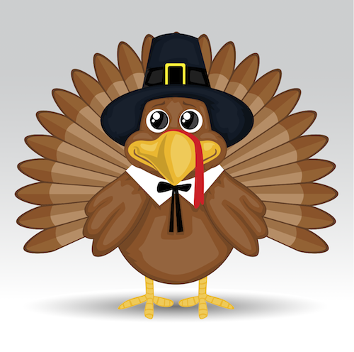
Penne Pasta with Meat Sauce
OR Penne Chicken Alfredo
Garlic Breadstick
Parmesan Cheese
Glazed Carrots, Garden Salads
Pineapple Tidbits, Strawberries
Juice, Milk

Hot Dog
OR Chili Coney
Shredded Cheese, Diced Onion
Onion Rings, Green Beans
Cucumbers & Red Peppers
Peaches, Sidekicks
Juice, Milk

