
Hot Dog
Curly Fries
Sidekick
Milk

Student Lunch $3.20
Adult Lunch $5.00
Meal includes all listed items for that menu day


Alternate meal options include PB&J Grab & Go or Yogurt Grab & Go. Fruits & Vegetables served with all options.
Meat options not available on Fridays. Menu subject to change by product availability.
This institution is an equal opportunity employer.

Cheese Ravioli with Marinara
Garden Salad
Orange Slices
Milk

Hamburger
Pickle Slices
Baked Beans
Peaches
Milk

NOVEMBER 2025
St. Mary Preschool Lunch Menu
No School
Soft Tacos
Shredded Cheese, Lettuce
Corn
Pineapple
Milk

Chicken Nuggets
Macaroni & Cheese
Green Beans
Pears
Milk

Chicken Tenders
Mashed Potatoes & Gravy
Pears
Milk

Chili Spaghetti
Cheese, Oyster Crackers
Carrot Sticks
Mandarin Oranges
Milk

Cheese Pizza
Steamed Broccoli
Strawberries
Milk

Hamburger
Pickle Slices
Baked Beans
Peaches
Milk

Grilled Cheese Sandwich
Pickle Spears, Oyster Crackers
Tomato Soup
Orange Slices
Milk

Roasted Turkey
Mashed Potatoes & Gravy
Pears
Milk

Mini Corn Dogs
Carrot Sticks
Mandarin Oranges
Milk

Cheese Pizza
Steamed Broccoli
Strawberries
Milk

Confetti Pancakes
Egg Omelet
Celery Sticks
Apples
Milk

Pizza Crunchers
Marinara Sauce
Garden Salad
Applesauce
Milk

No School
Happy Thanksgiving!
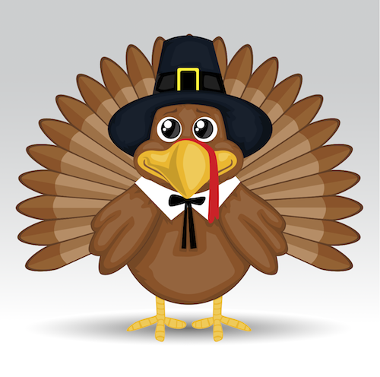
Crispito
Corn
Pineapple
Milk

Chicken Patty Sandwich
Pickle Slices
Curly Fries
Sidekick
Milk

