
Student Lunch $3.20
Adult Lunch $5.00
Meal includes all listed items for that menu day


Alternate meal options include PB&J Grab & Go or Yogurt Grab & Go. Fruits & Vegetables served with all options.
Meat options not available on Fridays. Menu subject to change by product availability.
This institution is an equal opportunity employer.

No School
Christmas Break Begins
No School
Chicken Nuggets
Macaroni & Cheese
Green Beans
Pears
Milk

Confetti Pancakes
Egg Omelet
Celery Sticks
Apples
Milk

Soft Tacos
Shredded Cheese, Lettuce
Corn
Pineapple
Milk

Feast of the
Immaculate Conception
No School
DECEMBER 2025
St. Mary Preschool Lunch Menu
Hamburger
Pickle Slices
Baked Beans
Peaches
Milk

Cheese Pizza
Steamed Broccoli
Strawberries
Milk

Chili Spaghetti
Cheese, Oyster Crackers
Carrot Sticks
Mandarin Oranges
Milk

Chicken Tenders
Mashed Potatoes & Gravy
Pears
Milk

Grilled Cheese Sandwich
Pickle Spears, Oyster Crackers
Tomato Soup
Orange Slices
Milk

Hamburger
Pickle Slices
Baked Beans
Peaches
Milk

Cheese Pizza
Steamed Broccoli
Strawberries
Milk

Mini Corn Dogs
Carrot Sticks
Mandarin Oranges
Milk

Chicken Drumstick
Mashed Potatoes & Gravy
Pears
Milk

Cheese Ravioli with Marinara
Garden Salad
Orange Slices
Milk

Pizza Crunchers
Marinara Sauce
Garden Salad
Applesauce
Milk

No School
No School
Merry Christmas!
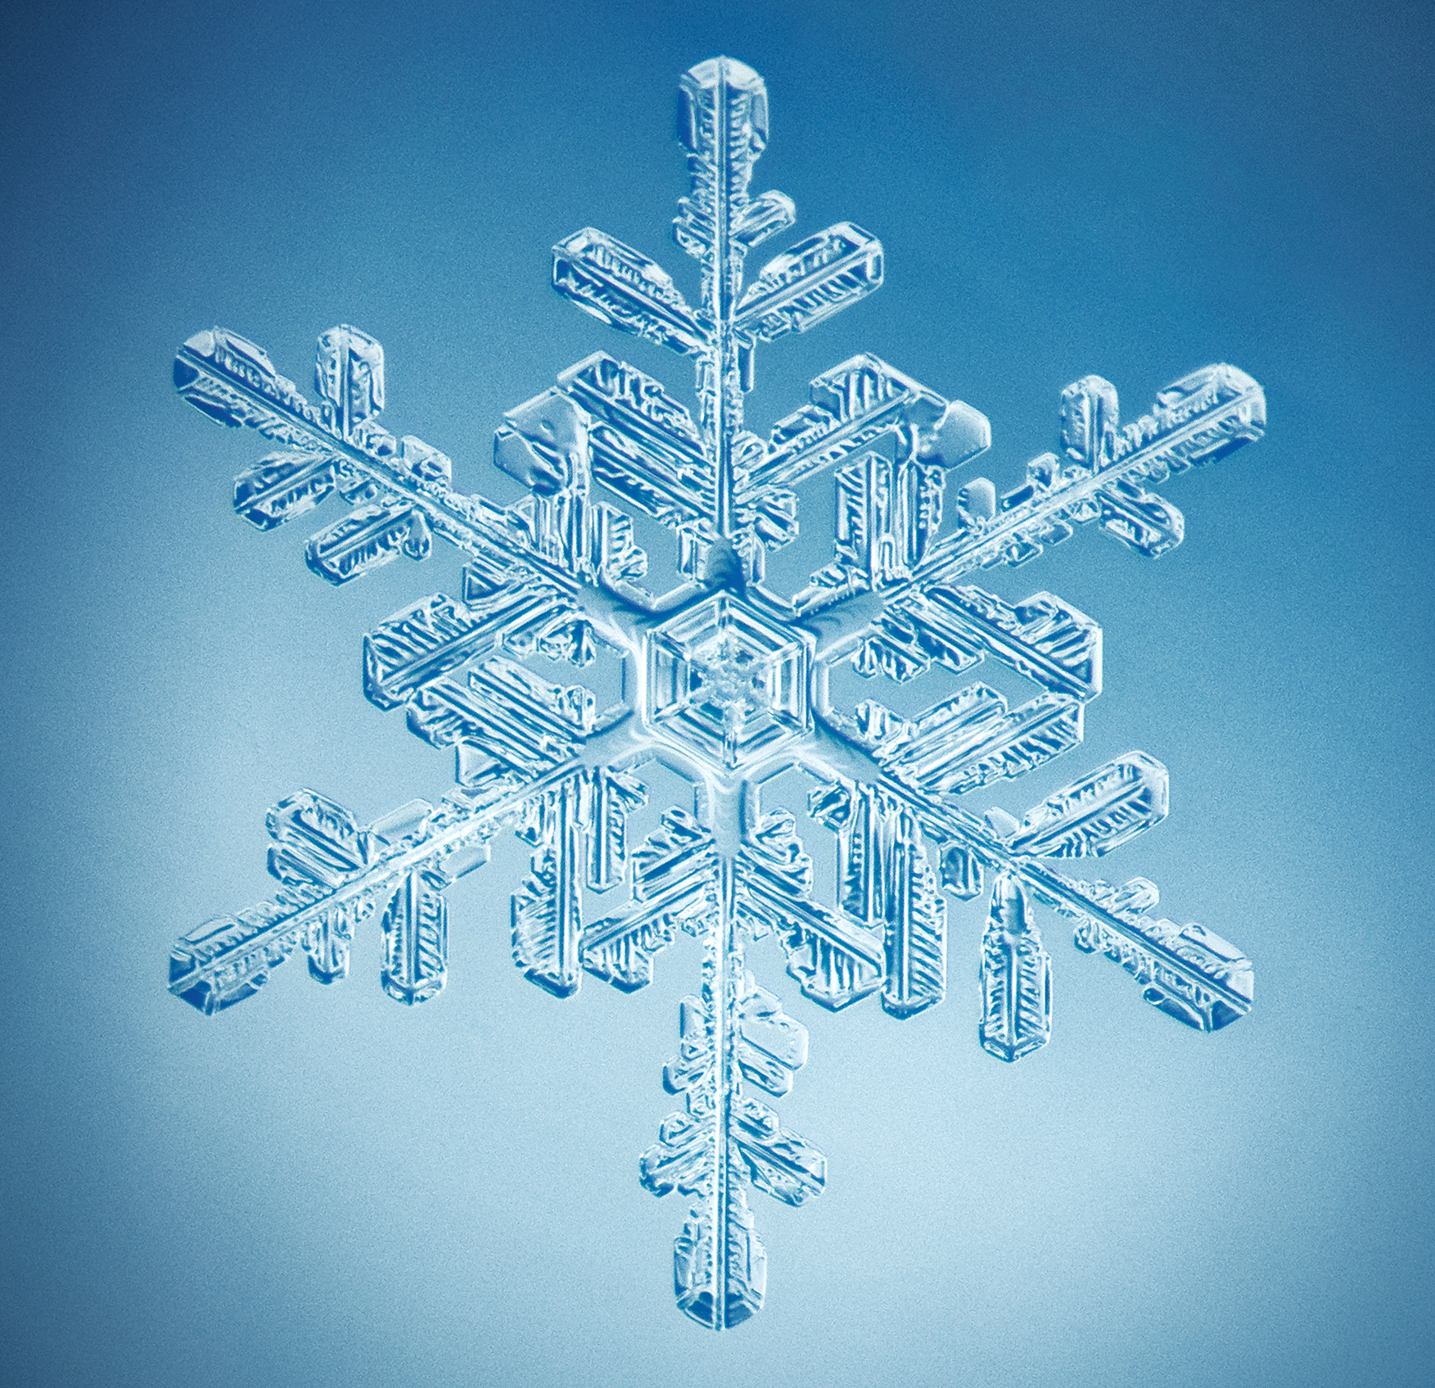
No School
No School
No School

